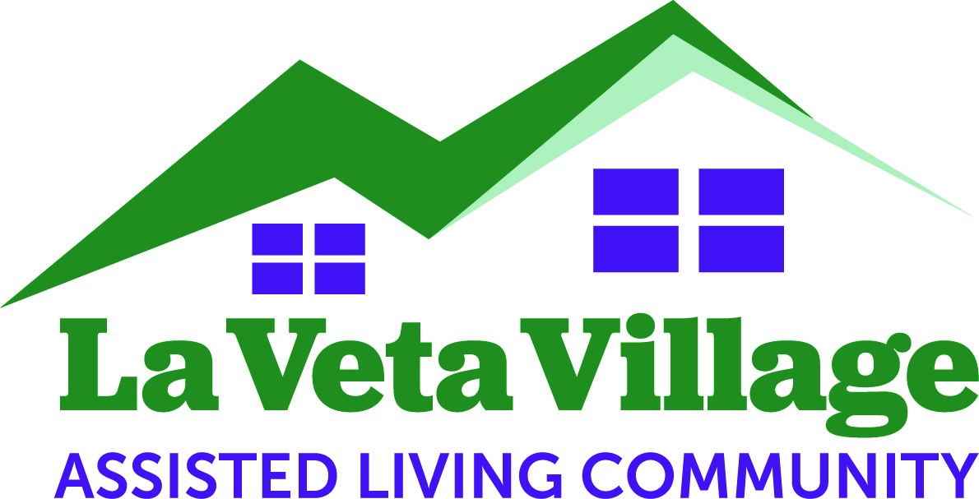 Date: _________________

APPLICATION FOR RESIDENCY
(ALL INFORMATION WILL REMAIN CONFIDENTIAL AND DOES NOT OBLIGATE ME TO MOVE TO LA VETA VILLAGE)

I am interested in living at La Veta Village (LVVI) in the future. My family and I agree that I will benefit from the supportive services and meals the Village offers. I anticipate being independently mobile, or in need of minimal assistance. LVVI offers me the ability to remain close to family and long-time friends. I understand LVVI will strive to accommodate residents of all income levels.

Who is completing this form: ____Self ______Family Member (name: ____________________________)
Prospective Resident:________________________________________________________________________________
Name Address City/State/Zip
______________________________________________________________________________
Phone # Age Gender
Present Living Situation: ___Live Independently ___Live with Spouse/Friend ___Live with Grown Children
___Other, Please Explain ________________________________________________________
Self-Administer Own Medications: ___Yes ___No
Do you need assistance with some things now? ___Grocery Shopping/Cooking ___Meds ___Bathing/Dressing
___Paying bills ___Housecleaning ___Yard Work ___Other ______________________________________________
Please Place Me on the Waiting List: ___ How soon do you anticipate needing Assisted Living? _______(mos/yrs)
What interests and/or skills would you bring to the resident community? _______________________________________
What are your favorite activities? ______________________________________________________________________
What services would you like available?_________________________________________________________________
What other information do you feel is important to share with us? (Please use back if necessary)_____________________ __________________________________________________________________________________________________
How can we keep you informed? ___U.S. Mail ___ email: ________________________________________________
Would you like to be notified of project updates? ___Yes ___No Monthly Programs? ___Yes ___No
Contact Information:_________________________________________________________________________
Name Phone # Relationship

